Making an Anemometer

Subject:  Related Subjects: | Grade Level(s):  Length of Lesson: | Type: Inquiry / Design / Project  Keywords:

Lesson Overview
Use this section to describe at a high level what the lesson is. Should be no more than 3-4 lines.

Lesson Focus
Today we will build our very own anemometer!
- You can take your anemometer outside and measure the speed of the wind by seeing how many times your device makes a revolution, or goes around in a complete circle.

Lesson Objective(s) | Learn about instruments to measure weather and build an anemometer out of simple supplies.  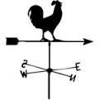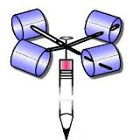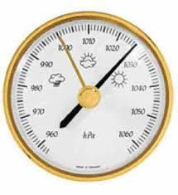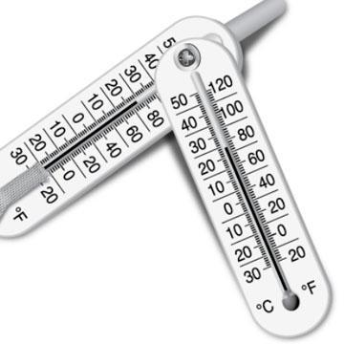  Wind vane Anemometer Barometer Psychrometer

Lesson Timing

5 minutes | Introduce the Lesson
30 minutes | ...

Materials | - -5 small paper cups  - -wooden stick  - -2 straws  - -push pin  - -hole puncher  - -clay  - -duct tape  - -scissors
Instructor Prep | - Step 1
Related Resources | - List related lessons/ppts etc available from USC or outside, trusted orgs

Lesson Plan

Introduction
- Wind vanes tell you which direction the wind is blowing (North, South, East, West, NorthEast, etc.)
- Anemometers are devices that measure the speed of the wind
- Barometers measure the humidity level in the air
(Humidity-the measure of the amount of water vapor in the air.
For rain clouds to form, the air has to reach 100% humidity! Barometers measure humidity in the air!)
- Psychrometers measure relative humidity. They have two thermometers, one with a dry bulb that measures the normal temperature of air, and a wet bulb that measures the temperature of liquid. With a psychrometer, we can compare the temperatures of gases and liquids to calculate relative humidity.
A cup anemometer is called a Robinson anemometer

Procedure

- Punch 4 holes in one of the paper cups that will be used in the center
- In the other 3 cups, punch only one hole on the sides
- Take the two straws and insert each through 2 holes in the center cup with 4 holes, these straws should cross and make an X in the center
- Place the 4 straw ends in the holes of the other 4 cups, make sure the cups are pointing in the same direction
- Use duct tape to keep straw ends and the cups in place
- Color one of the 4 cups at the bottom as a reference point for determining how many spins occur
- Cut a hole at the bottom of the middle cup to pass the wooden stick through
- Push the wooden stick up until it meets the X formed by the straws
- Use the push pin to put the straw X and top of wooden stick together
- The top portion should now be able to spin freely when holding the wooden stick and blowing at the cups
- Use modeling clay to keep the anemometer in place over any surface

Wrap-up
End the lesson with some final discussions about what students designed/discovered. Connect their activity back to the focus question/problem, real world examples, and STEM careers.

Also include notes about any special cleanup considerations

Lesson Background for Teachers

Suggested Real-World STEM Connections
- List possible related Role Models in STEM (with details and links to more reading). Give suggestions for examples of scientists/engineers who are from underrepresented groups in STEM in related careers.
- List related real-world engineering problems and examples

Lesson Variations and Options
Include descriptions of alternative methods or ways to present things.

Explanation
Describe the background concepts and explanations behind the lesson. This can be more in depth than a teacher/instructor would actually share with students.

Key Concepts and Vocabulary
- Word 1: Grade Appropriate Definition
- Word 2: Grade Appropriate Definition

Safety Notes
- Safety instruction

